[Connecting Chrome Extension with Python Backend | by Faria Huq | Medium](https://medium.com/@oaishi.faria/connecting-chrome-extension-with-python-backend-912d1d0db26)

Setup cross-origin connection for chrome extension to communicate with Django server run locally.

Django3.0 for python3.7

Steps:

* Install python
  + <https://docs.djangoproject.com/en/3.0/faq/install/#faq-python-version-support>
* Install Django
  + python -m pip install Django
  + python -m django --version
* Github
  + <https://github.com/gyanggh/gaaskprj.git>
* Install git
* (Git django code)
  + D:\MCS-DS\cs410\Project
  + git clone <https://github.com/django/django.git>
* Setup Django server
  + Richard’s machine, cmd, cd to D:\MCS-DS\cs410\Project
  + <https://medium.com/@oaishi.faria/connecting-chrome-extension-with-python-backend-912d1d0db26>
  + <https://docs.djangoproject.com/en/3.0/intro/tutorial01/>
    - Create site: django-admin startproject mysite
    - **$** python manage.py runserver
    - **$** python manage.py startapp polls
  + pip install wikipedia
  + python manage.py startapp wiki
  + path('get_wiki_summary/', views.get_wiki_summary, name='get_wiki_summary'),
    - [http://127.0.0.1:8000/wiki/get_wiki_summary/?topic=“*meme*](http://127.0.0.1:8000/wiki/get_wiki_summary/?topic=“meme)”
* Set up Chrome Extension
  + <https://www.youtube.com/playlist?list=PLC3y8-rFHvwg2-q6Kvw3Tl_4xhxtIaNlY>
  + mkdir D:\MCS-DS\cs410\Project\mychromeext
  + 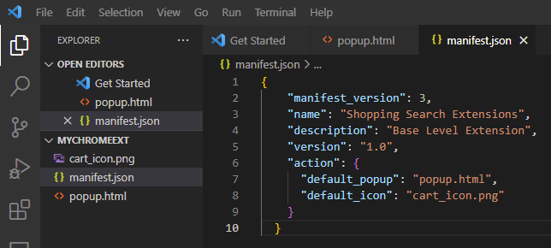
  + Update chrome to latest version (may need uninstall then install chrome)
  + How do I create a Google extension?
  + Go to **chrome://extensions** in your Google Chrome browser. Check the Developer mode checkbox in the top right-hand corner. Click “Load Unpacked” to see a file-selection dialog. Select your extension directory
* Setup Cross-Origin connection
  + <https://developer.chrome.com/docs/extensions/mv3/xhr/>
  + <https://developer.chrome.com/docs/extensions/mv3/messaging/>
  + the server reply as an alert/notification
  + add Permission to access the Localhost in the manifest file
    - *"host_permissions": [*[*http://127.0.0.1:8000/*](http://127.0.0.1:8000/)*],*
  + **Troubleshooting – see errors in chrome extension’s “Error”**
    - [**oaishi/WikiSearch (github.com)**](https://github.com/oaishi/WikiSearch)
      * Git clone to - **D:\MCS-DS\CS410\Project\WikiSearch**
    - [Google chrome extension manifest v3 for beginners | by That IT Guy 👨🏻‍💻 | Dev Genius (medium.com)](https://medium.com/dev-genius/google-chrome-extension-manifest-v3-for-beginners-25494ab268bb)
    - Chrome extension v3 version background service worker deep analysis
      * [*https://blog.csdn.net/wangsenling/article/details/124137125?ops_request_misc=%257B%2522request%255Fid%2522%253A%2522166840775516782388023820%2522%252C%2522scm%2522%253A%252220140713.130102334.pc%255Fall.%2522%257D&request_id=166840775516782388023820&biz_id=0&utm_medium=distribute.pc_search_result.none-task-blog-2~all~first_rank_ecpm_v1~rank_v31_ecpm-1-124137125-null-null.142^v63^control,201^v3^control_1,213^v2^t3_control1&utm_term=django%20chrome%20extension&spm=1018.2226.3001.4187*](https://blog.csdn.net/wangsenling/article/details/124137125?ops_request_misc=%257B%2522request%255Fid%2522%253A%2522166840775516782388023820%2522%252C%2522scm%2522%253A%252220140713.130102334.pc%255Fall.%2522%257D&request_id=166840775516782388023820&biz_id=0&utm_medium=distribute.pc_search_result.none-task-blog-2~all~first_rank_ecpm_v1~rank_v31_ecpm-1-124137125-null-null.142^v63^control,201^v3^control_1,213^v2^t3_control1&utm_term=django%20chrome%20extension&spm=1018.2226.3001.4187)
* Steps:
  + Cmd; D:; cd D:\MCS-DS\CS410\Project\WikiSearch
  + Cd mysite
  + python manage.py runserver
  + Test in browser:
    - [http://127.0.0.1:8000/wiki/get_wiki_summary/?topic=“*meme*](http://127.0.0.1:8000/wiki/get_wiki_summary/?topic=“meme)”
  + Setup chrome extension:
    - In Chrome, chrome://extensions -> Load unpacked -> open directory D:\MCS-DS\CS410\Project\WikiSearch\WikiExtension
    - Change code:
      * In vs code, change manifest.json:
        + From: "manifest_version": 2,
        + To: "manifest_version": 3,
      * In Chrome extension, click Update to update this loaded extension
      * 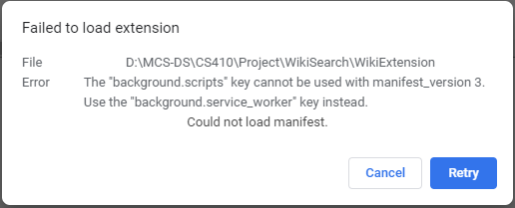
      * Change
        + from:

"background": {

"scripts": ["background.js"],

"persistent": false

},

* + - * + To

"background": {

"server_worker": ["background.js"],

"persistent": false

},

* + - * 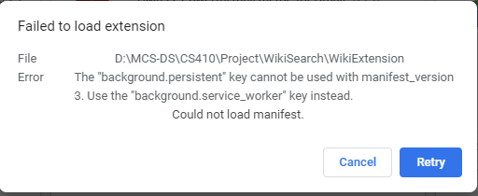
      * Remove below in manifest.json:
        + , "persistent": false
      * Click extension Update:
        + 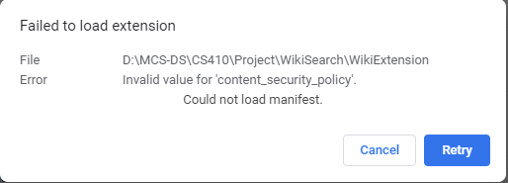
        + <https://stackoverflow.com/questions/63308160/how-to-migrate-manifest-version-2-to-v3-for-chrome-extension>

<https://developer.mozilla.org/en-US/docs/Mozilla/Add-ons/WebExtensions/manifest.json/content_security_policy>

<https://stackoverflow.com/questions/67130826/why-am-i-getting-failed-to-load-extension-invalid-value-for-content-security>

<https://developer.chrome.com/docs/extensions/mv3/mv3-migration/>

<https://stackoverflow.com/questions/67439012/chrome-extension-manifest-v3-content-security-policy>

So, additional changes From:

{

"manifest_version": 3,

"name": "Wiki Search",

"description": "This extension gives you a summary from WikiPedia.",

"version": "1.0",

"icons": {

"128": "icon128.png",

"48": "icon48.png",

"16": "icon16.png"

},

"browser_action": {

"default_icon": "icon16.png",

"default_popup": "popup.html"

},

"background": {

"server_worker": ["background.js"]

},

"content_security_policy": "script-src 'self' https://*.google.com 'unsafe-eval'; object-src 'self'",

"permissions": [

"tabs",

"http://127.0.0.1:8000/",

"background",

"identity",

"notifications"

]

}

To:

{

"manifest_version": 3,

"name": "Wiki Search",

"description": "This extension gives you a summary from WikiPedia.",

"version": "1.0",

"icons": {

"128": "icon128.png",

"48": "icon48.png",

"16": "icon16.png"

},

"action": {

"default_icon": "icon16.png",

"default_popup": "popup.html"

},

"background": {

"server_worker": "background.js"

},

"content_security_policy": {

"extension_pages": "script-src 'self'; object-src 'self'",

"sandbox": "sandbox allow-scripts; script-src 'self' 'https://*.google.com/'; object-src 'self'"

},

"permissions": [

"tabs",

"background",

"identity",

"notifications"

],

"host_permissions": [

"http://127.0.0.1:8000/"

]

}

* + - * Run Extension:
        + **Error:**

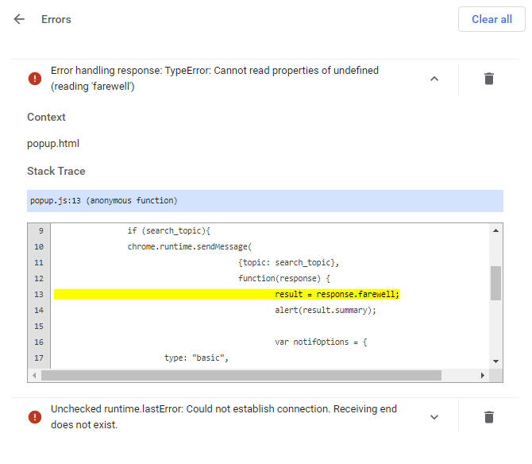

How to debug it?

Send message to communicate from extension to the server w/ python

* + - * Note: [The transition of Chrome extensions to Manifest V3 - Chrome Developers](https://developer.chrome.com/blog/mv2-transition/)
* Notes
  + Richard’s machine - D:\mcs-ds\cs410\project\grantsite
  + D:\MCS-DS\CS410\Project\grantsite
  + python manage.py runserver
  + [http://127.0.0.1:8000/wiki/get_wiki_summary/?topic=“*meme*](http://127.0.0.1:8000/wiki/get_wiki_summary/?topic=“meme)”
  + 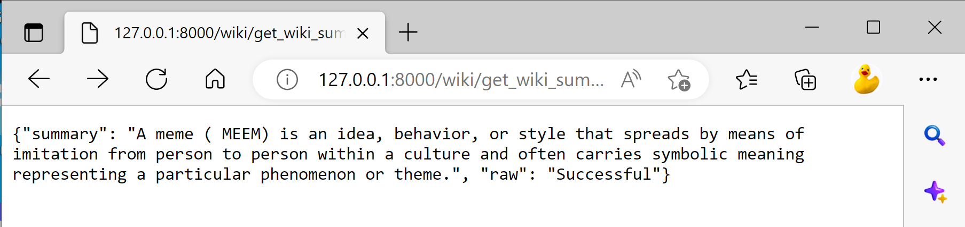
* Timeline
  + Due 11/16:
    - GitHub repo with readme for Django (grantsite in D: drive)
    - Complete Django practice
* Challenge:
  + How to run python to call scraper?
  + How to run chrome extension to connect to django server that use python?
  + How to run the virtual Django server on github (or, azure vm)?
* Reference:
  + <https://blog.csdn.net/weixin_31545945/article/details/114490999?ops_request_misc=&request_id=&biz_id=102&utm_term=Connecting%20Chrome%20Extension%20wi&utm_medium=distribute.pc_search_result.none-task-blog-2~all~sobaiduweb~default-1-114490999.142^v63^control,201^v3^control_1,213^v2^t3_control1&spm=1018.2226.3001.4187>